**Session 1**

**Assignment 1.6**

Student Name: Karthik K

Course: Big Data Hadoop & Spark Training

**Assignment 1.6** –We have a dataset of sales of different TV sets across different locations. Records look like:

**Samsung|Optima|14|Madhya Pradesh|132401|14200**

The fields are arranged like:

Company Name|Product Name|Size in inches|State|Pin Code|Price

There are some invalid records which contain 'NA' in either Company Name or Product Name.

1. Write a Map Reduce program to filter out the invalid records. Map only job will fit for this Context.

**Solution:**

**Driver Code:**

**package InvalidRecords;**

**import org.apache.hadoop.conf.Configuration;**

**import org.apache.hadoop.fs.Path;**

**import org.apache.hadoop.mapreduce.Job;**

**import org.apache.hadoop.mapreduce.lib.input.FileInputFormat;**

**import org.apache.hadoop.mapreduce.lib.input.TextInputFormat;**

**import org.apache.hadoop.mapreduce.lib.output.FileOutputFormat;**

**import org.apache.hadoop.mapreduce.lib.output.TextOutputFormat;**

**import org.w3c.dom.Text;**

**public class InvalidRecord**

**{**

**public static void main(String[] args) throws Exception**

**{**

**Configuration conf=new Configuration();**

**Job job=new Job(conf, "Invalid Data");**

**job.setJarByClass(InvalidRecord.class);**

**job.setMapOutputKeyClass(Text.class);**

**job.setMapOutputValueClass(Text.class);**

**job.setMapperClass(InvalidRecordsMapper.class);**

**job.setNumReduceTasks(0);**

**job.setInputFormatClass(TextInputFormat.class);**

**job.setOutputFormatClass(TextOutputFormat.class);**

**FileInputFormat.addInputPath(job,new Path(args[0]));**

**FileOutputFormat.setOutputPath(job,new Path(args[1]));**

**job.waitForCompletion(true);**

**}**

**}**

Mapper Code:

**package** InvalidRecords;

**import** java.io.IOException;

**import** org.apache.hadoop.io.LongWritable;

**import** org.apache.hadoop.io.Text;

**import** org.apache.hadoop.mapreduce.Mapper;

**public** **class** InvalidRecordsMapper **extends** Mapper<LongWritable,Text,Text,Text>

{

**public** **void** map(LongWritable key,Text value,Context context) **throws** IOException, InterruptedException

{

String line=value.toString();

String[]linearray=line.split("\\|");

**if**(!(linearray[0].equals("NA")||linearray[1].equals("NA")))

{

context.write(**new** Text(line), **new** Text());

}

}

}

### **Input**

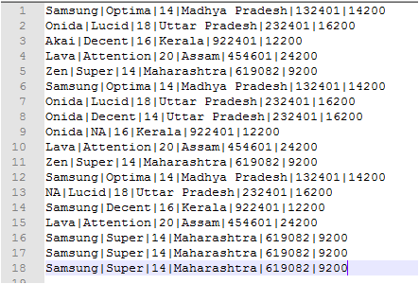

### **Output**

